Bahria University,

Karachi Campus



LAB EXPERIMENT NO.

**12**

LIST OF TASKS

|  |  |
| --- | --- |
| TASK NO | OBJECTIVE |
| 1 | **Saving customized key-value pair: Create an app by which user can set and get customized key-value pair.** |
| 2 | **Create an app which can save user comments recorder by using SharedPreferences. User must be able to see previous comments chronologically.** |
|  |  |

**Task 1: Saving customized key-value pair: Create an app by which user can set and get customized key-value pair.**

**Solution:**

**Design:**

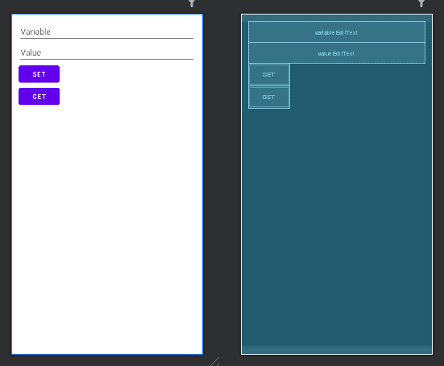

**Code:**

**MainActivity Class:**

public class MainActivity extends AppCompatActivity {

private EditText variableEditText, valueEditText;

private Button setButton, getButton;

private SharedPreferences sharedPreferences;

@Override

protected void onCreate(Bundle savedInstanceState) {

super.onCreate(savedInstanceState);

setContentView(R.layout.activity_main);

variableEditText = findViewById(R.id.variableEditText);

valueEditText = findViewById(R.id.valueEditText);

setButton = findViewById(R.id.setButton);

getButton = findViewById(R.id.getButton);

sharedPreferences = getSharedPreferences("KeyValuePairs", MODE_PRIVATE);

setButton.setOnClickListener(new View.OnClickListener() {

@Override

public void onClick(View v) {

String variable = variableEditText.getText().toString();

String value = valueEditText.getText().toString();

SharedPreferences.Editor editor = sharedPreferences.edit();

editor.putString(variable, value);

editor.apply();

Toast.makeText(MainActivity.this, "Key-Value pair set successfully", Toast.LENGTH_SHORT).show();

}

});

getButton.setOnClickListener(new View.OnClickListener() {

@Override

public void onClick(View v) {

String variable = variableEditText.getText().toString();

String value = sharedPreferences.getString(variable, "");

if (value.isEmpty()) {

Toast.makeText(MainActivity.this, "Value not found for the key", Toast.LENGTH_SHORT).show();

} else {

Toast.makeText(MainActivity.this, "Value: " + value, Toast.LENGTH_SHORT).show();

}

}

});

}

}

**Output:**

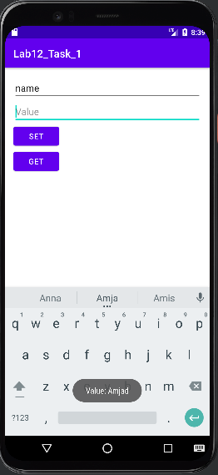

**Task 2: Create an app which can save user comments recorder by using Shared Preferences. User must be able to see previous comments chronologically.**

**Solution:**

**Design:**

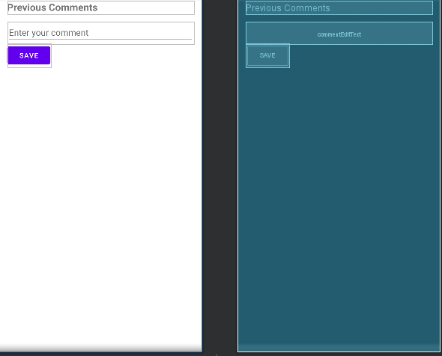

**Code:**

**MainActivity Class:**

public class MainActivity extends AppCompatActivity {

private TextView commentsTextView;

private EditText commentEditText;

private Button saveButton;

private SharedPreferences sharedPreferences;

private static final String PREFS_NAME = "CommentPrefs";

private static final String COMMENTS_KEY = "Comments";

@Override

protected void onCreate(Bundle savedInstanceState) {

super.onCreate(savedInstanceState);

setContentView(R.layout.activity_main);

commentsTextView = findViewById(R.id.commentsTextView);

commentEditText = findViewById(R.id.commentEditText);

saveButton = findViewById(R.id.saveButton);

sharedPreferences = getSharedPreferences(PREFS_NAME, MODE_PRIVATE);

displayPreviousComments();

saveButton.setOnClickListener(new View.OnClickListener() {

@Override

public void onClick(View v) {

String comment = commentEditText.getText().toString();

saveComment(comment);

}

});

}

private void saveComment(String comment) {

String existingComments = sharedPreferences.getString(COMMENTS_KEY, "");

String newComments = existingComments + "\n" + comment;

SharedPreferences.Editor editor = sharedPreferences.edit();

editor.putString(COMMENTS_KEY, newComments);

editor.apply();

appendCommentToTextView(comment);

commentEditText.setText("");

}

private void displayPreviousComments() {

String existingComments = sharedPreferences.getString(COMMENTS_KEY, "");

commentsTextView.setText(existingComments);

}

private void appendCommentToTextView(String comment) {

String existingComments = commentsTextView.getText().toString();

String newComments = existingComments + "\n" + comment;

commentsTextView.setText(newComments);

}

}

**Output:**

